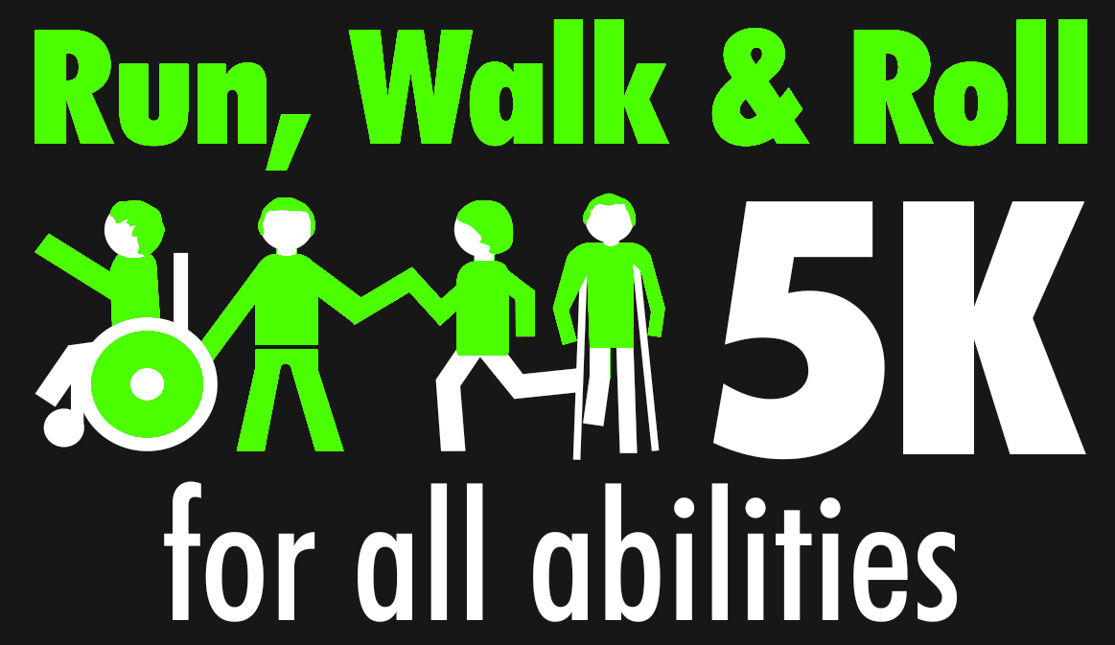

**Second Annual Run, Walk, & Roll 5k for All Abilities**

**Sunday, April 24th, 2016 @ 4:00pm**

**Event will occur rain or shine**

**Where:**  Registration and Race Start and Finish at the Selinsgrove School District Track

N. Magnolia Drive, Selinsgrove, PA 17870

**Registration Fee:**  $20 Early Registration

$25 Late Registration

T-shirt provided to all participants registered by Friday, April 10th

**Registration Information:** Register online @ active.com or mail paper form with check or cash

**Race Information:** The second annual **Run, Walk, and Roll 5k for All Abilities** will be held on the campus of Selinsgrove School District. The race will begin on the high school track, with the accessible portion remaining on the track, while runners take a course off of the track. All runners, walkers, and rollers will finish on the track. Prizes will be awarded to 1st, 2nd, and 3rd place finishers for both men and women. All proceeds will benefit the Selinsgrove School District's Life Skills Program, which helps people with disabilities learn independent living skills so that they may become successful members within their community!

**Further Information:** Ashley: [awhary@gmail.com](mailto:awhary@gmail.com)

**Make checks payable to** *SEALS DEN*

**Mail to:** *Selinsgrove High School, c/o Ashley Whary, 500 N. Broad Street, Selinsgrove, PA 17870*

**Name: ___________________________________________________ Age: _____________ Gender: _____________**

**Address: __________________________________________________ Phone: ________________________________**

**Email: __________________________________________________ T-Shirt Size:** Small Medium Large XLarge 2XL

*I hereby release Selinsgrove Area School District, the Run, Walk & Roll 5k organizers, officials, and any other coordinating group or member associated with the event from any claim of damage or injury resulting from my participation in or traveling to or from the event. I further attest that I am in proper physical condition to participate in the event.*

**Signature: ____________________________________________________ Date: ______________________________**