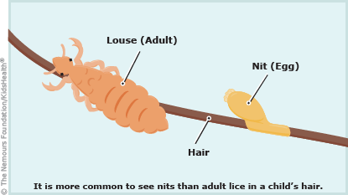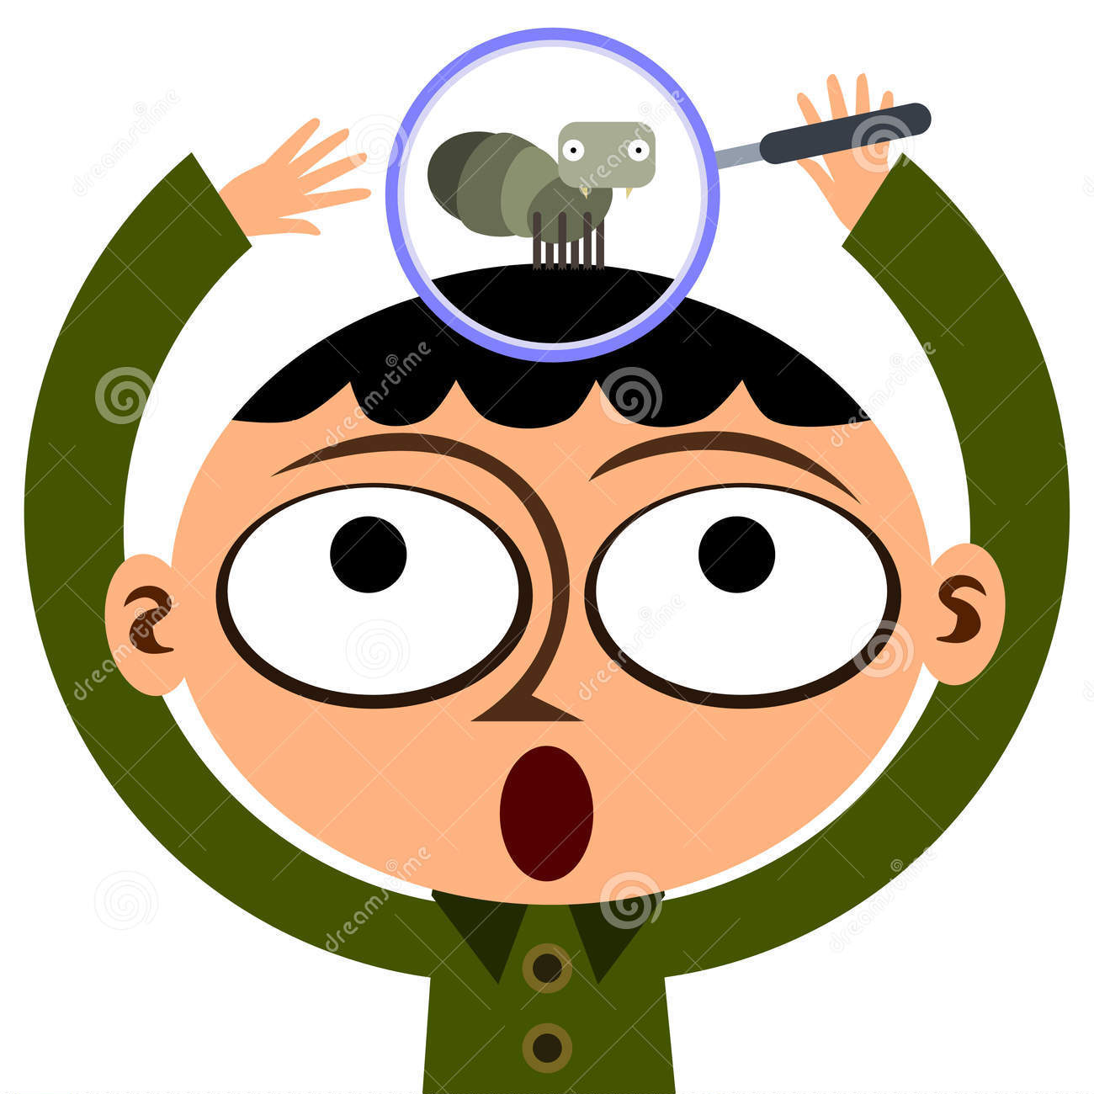 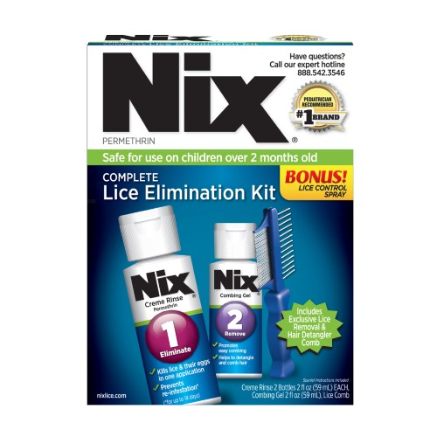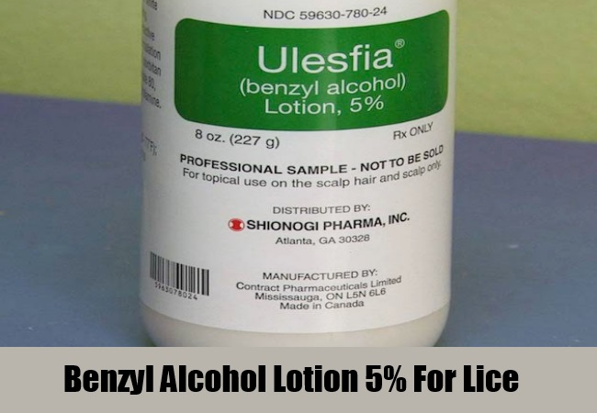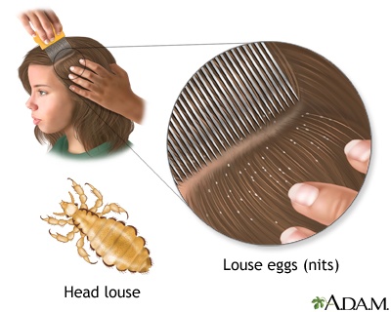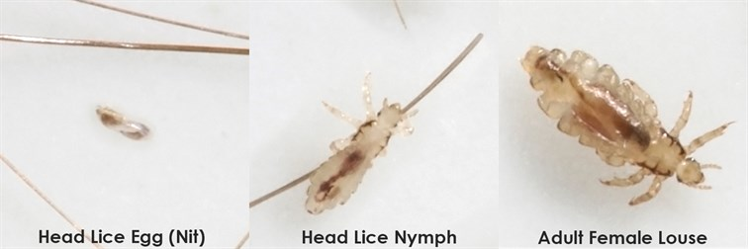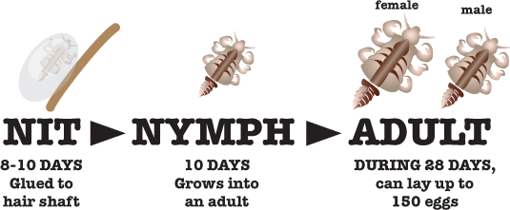

## References

Selinsgrove School District

<https://www.healthychildren.org/English/health-issues/conditions/from-insects-animals/Pages/Signs-of-Lice.aspx>

<https://www.healthychildren.org/English/health-issues/conditions/from-insects-animals/Pages/Head-Lice-Treatment-Myths-Realities.aspx>

<https://www.ndhealth.gov/head-lice/publications/myths_and_facts.pdf>

<https://www.cdc.gov/parasites/lice/head/treatment.html>

<https://www.cdc.gov/parasites/lice/head/parents.html>

<https://www.cdc.gov/parasites/lice/head/gen_info/faqs.html>

* Head lice is a parasitic insect
* They feed on human blood and live close to the scalp
* They do not spread disease
* About 6 million to 12 million people in the US get head lice each year!
* Most common in ages 3-11
* Being spread through objects (clothing, hats, scarves, combs, brushes, towels) is NOT common
* Being clean/dirty has nothing to do with it
* Head lice can only crawl… they CANNOT hop, jump, or fly
* Most likely are spread by direct head-to-head contact

### Facts

Head Lice

*Home remedies to treat lice are safe and effective*

* FALSE: Home remedies such as mayonnaise, butter, and olive oil have not been proven to be effective in treating lice. Always call your doctor first to decide which treatment to use.

*Prescription head lice treatments should be left on the head for 8-12 hours*

* FALSE: All prescription application times are different. Some are even as short as 10 minutes. This is why it’s important to read the instructions on the box or label.

*Over the counter (OTC) treatments sometimes aren’t always the best*

* TRUE: Some OTC treatments may not kill the head lice due to the active ingredients found in them. Contact your doctor first to help you decide which treatment to use.

Checking for Lice:

* Hairline at back of neck or behind ears
* Nits are firmly attached to hair
* Small white or yellow-brown specks attached to hair near scalp
* Part hair into sections
* Lice avoid light and move fast

Symptoms:

* Itching
* Tickling
* Trouble sleeping
* Sores on head from scratching

# True or False

Treatment Options

More Info

-Wash linens, towels, clothes, etc. in hot water and dry on high heat

-Do not spray pesticides in the home, they have dangerous chemicals

- Check other household members for lice

-Vacuum floor and furniture

Always check with your doctor first before treating!

**Over-the-Counter:**

*Permethrin lotion (1%) Brand: Nix*

*Pyrethrin-based product Brand: A-200, Licide, R&C, RID, Triple X*

**Prescription:**

*Benzyl alcohol lotion (5%)*

*Brand: Ulesfia lotion*

*Spinosad topical suspension (0.9%) Brand: Natroba*

*Ivermectin lotion (0.5%) Brand: Sklice*